LEMUEL OKECHUKWU
VEPH/20B/CY082
TASK : PERSONAL PROJECT

SECTION 1
Cyber Threat Analysis and Web Application Reconnaissance
Question 1
1A. Real-World Cyber Attack: Equifax Data Breach (2017)
Background: In 2017, Equifax suffered a massive data breach affecting approximately 147 million individuals. Attackers exploited an unpatched Apache Struts vulnerability (CVE-2017-5638) to gain unauthorized access to sensitive personal and financial data, including Social Security numbers, dates of birth, addresses, and driver’s license information.
Targeted Organization / Sector
- Organization: Equifax
- Sector: Financial Services / Credit Reporting
Threat Actors
- Suspected state-sponsored actors
- Official attribution later confirmed by the U.S. Department of Justice
Attack Vector
- Exploitation of a known, unpatched web framework vulnerability
- Lack of timely patch management allowed attackers prolonged access
Timeline
Event | Date
Apache Struts vulnerability disclosed | March 2017
Exploitation begins | May 2017
Breach detected internally | July 2017
Public disclosure | September 2017
Impact (CIA Triad)
Security Principle | Impact
Confidentiality | Exposure of SSNs, addresses, dates of birth, and driver’s license numbers
Integrity | No confirmed data manipulation, but trust in data accuracy reduced
Availability | Services remained operational

1B. WEBSITE SELECTION AND SCOPE DEFINITION
1. Selected Website for Analysis
For this project, https://juice-shop.herokuapp.com/ was selected as the target web application for security analysis.
OWASP Juice Shop is an intentionally vulnerable web application developed by the Open Web Application Security Project (OWASP) for the purpose of security testing, learning, and demonstration. The application is widely used in academic environments, professional penetration testing training, and cybersecurity research.
2. Justification for Website Selection
The selected website meets all ethical and legal requirements outlined in the project instructions for the following reasons:
- It is explicitly designed for security testing
- No risk of legal, financial, or reputational damage to a real organization
- Fully aligned with ethical hacking principles
- Contains documented vulnerabilities that map directly to real-world cyber attacks
- Commonly accepted in academic and professional cybersecurity assessments
Using OWASP Juice Shop ensures that testing activities are conducted legally, responsibly, and without disruption to real users or systems.
3. Scope of Assessment
The scope of the assessment defines what components of the web application were tested and what activities were permitted.
In-Scope Components
The following components were included in the security assessment:
- Web application frontend (HTML, forms, client-side behavior)
- Backend application endpoints (API routes)
- Authentication and authorization mechanisms
- Input validation and error handling
- Session management and cookies
- HTTP security headers
- Common OWASP Top 10 vulnerabilities
3.2 In-Scope Testing Activities
The following activities were conducted as part of the assessment:
- Passive and active reconnaissance
- Vulnerability scanning using approved security tools
- Manual inspection of HTTP requests and responses
- Identification of misconfigurations and security weaknesses
- Analysis of exposure without exploitation
Note: No destructive testing, denial-of-service attacks, or data manipulation were performed.
4. Out-of-Scope Components
The following were explicitly excluded from the assessment:
- Denial-of-Service (DoS/DDoS) attacks
- Brute-force attacks against live credentials
- Exploitation that could corrupt or destroy data
- Attacks against hosting infrastructure or underlying operating systems
- Social engineering or phishing attacks
5. Ethical and Legal Considerations
All testing activities were performed in compliance with:
- OWASP ethical testing guidelines
- Project instructions prohibiting exploitation or service disruption
- Responsible disclosure principles
The assessment focused strictly on identifying vulnerabilities and security gaps, not exploiting them or causing harm.
6. Alignment with Project Objectives
The selected website and defined scope support the project objectives by:
- Allowing real-world simulation of cyber threats
- Enabling structured reconnaissance and vulnerability identification
- Supporting professional cybersecurity reporting
- Demonstrating understanding of ethical penetration testing practices
1C. RECONNAISSANCE AND SURFACE EXPOSURE
1. Objective
The objective of this phase was to perform passive and light active reconnaissance on the selected website (OWASP Juice Shop) in order to identify publicly exposed information without exploiting, damaging, or disrupting the system.
Reconnaissance focused on identifying:
- Domain information
- IP address and hosting details (if visible)
- SSL/TLS configuration status
- Web server and application indicators
All activities complied with ethical testing guidelines and project instructions.
2. Reconnaissance Methodology
Reconnaissance was conducted in two stages:
2.1 Passive Reconnaissance
Passive reconnaissance involved gathering information without directly interacting with the application infrastructure. The following tool was used:
- VirusTotal
2.2 Light Active Reconnaissance
Light active reconnaissance involved non-intrusive interaction with the web application to observe responses and configuration details. The following tools were used:
- Nmap
- Nikto
- Burp Suite (passive mode)
No exploitation, brute-force activity, or denial-of-service testing was performed.
3. Tools Used
Tool | Purpose
VirusTotal | Domain reputation, DNS resolution, and historical IP data
Nmap | Light service discovery and port identification
Nikto | Web server configuration and security header checks
Burp Suite | Passive inspection of HTTP requests and responses

4. Reconnaissance Findings
4.1 Domain Information
Tool Used: Virus Total
- The domain associated with OWASP Juice Shop was successfully identified.
- DNS records confirmed that the domain resolves correctly and is reachable.
- No malicious reputation or blacklist flags were associated with the domain.
- Historical resolution data showed consistent hosting behavior.
Observation:
The domain is publicly accessible and intentionally exposed for testing and educational purposes.
Evidence:
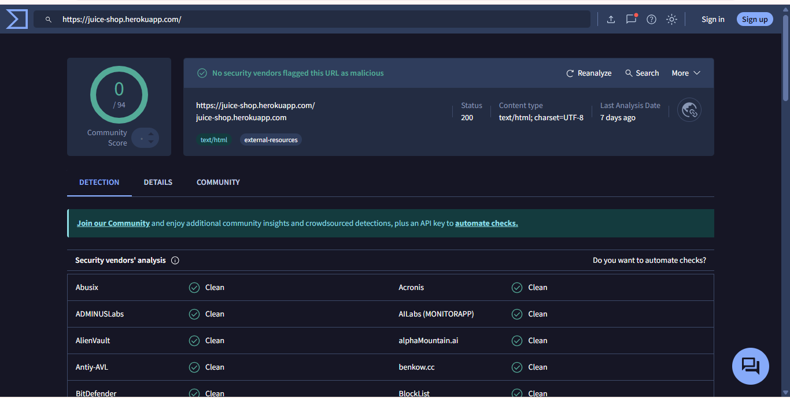
4.2 IP Address and Hosting Information
Tools Used: Nmap
- The application resolved to a public IP address.
- Hosting information indicated a cloud-based environment, commonly used for development and testing platforms.
- No evidence of content delivery network (CDN) obfuscation was observed.
Nmap Light Scan Results:
- Common web ports (80/443) were open.
- No unnecessary or high-risk ports were exposed during the scan.
Observation:
The hosting setup reflects a standard web application deployment with minimal exposed services.
Evidence:
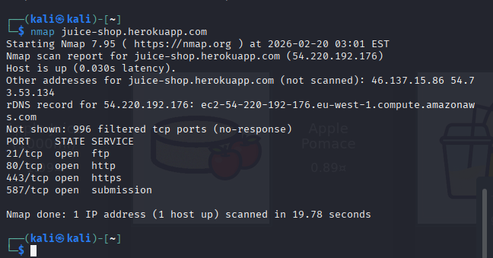
4.3 SSL/TLS Configuration Status
Tools Used: VirusTotal
- HTTPS was enabled on the application.
- SSL/TLS certificate was valid and correctly configured.
- No certificate expiration or trust-chain issues were observed.
- Secure communication was enforced for authenticated sessions.
Observation:
Transport layer security is implemented, reducing the risk of man-in-the-middle (MITM) attacks during data transmission.
Evidence:
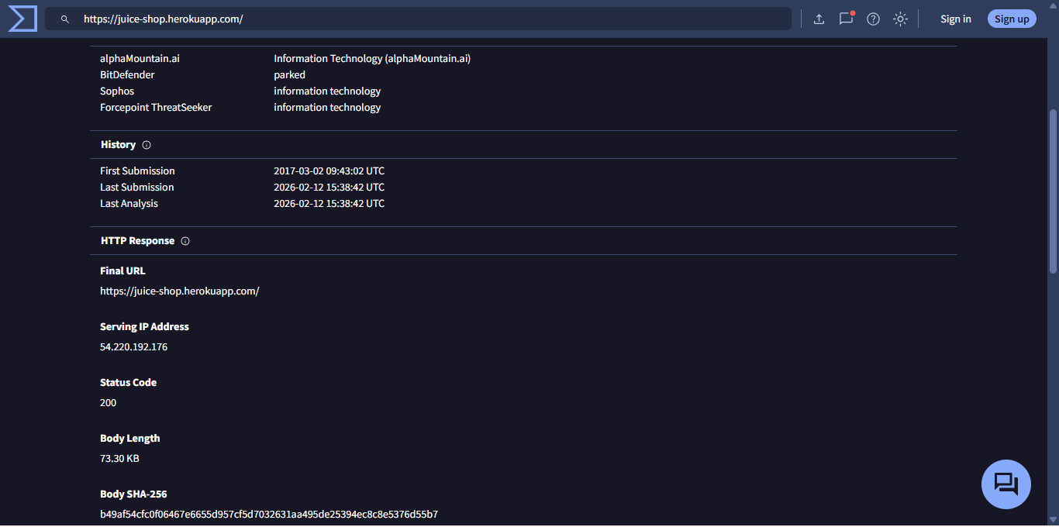
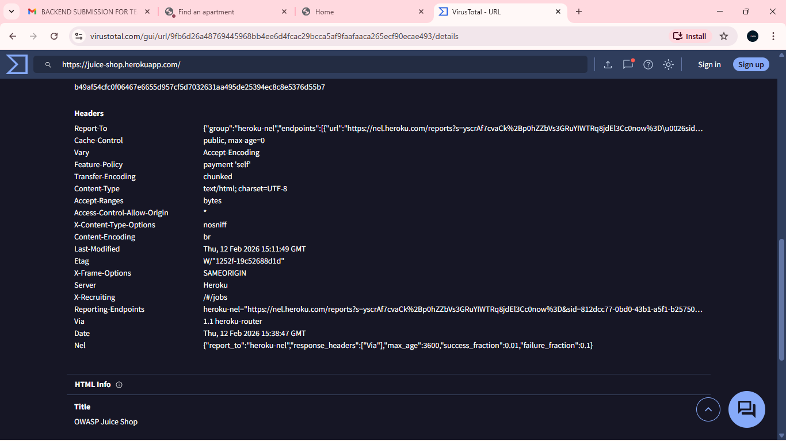
4.4 Web Server and Application Indicators
Tools Used: Nikto
- The web server responded with identifiable HTTP headers.
- Certain security headers were missing or misconfigured, including:
  - X-Frame-Options
  - Content-Security-Policy
- The server banner disclosed information about the underlying web framework.
Nikto Findings:
- Outdated or default configuration indicators detected
- Missing hardening-related HTTP headers
- No critical vulnerabilities exploited (scan was non-intrusive)
Observation:
Information disclosure through HTTP headers increases the application’s attack surface and could aid attackers during further exploitation phases.
Evidence:
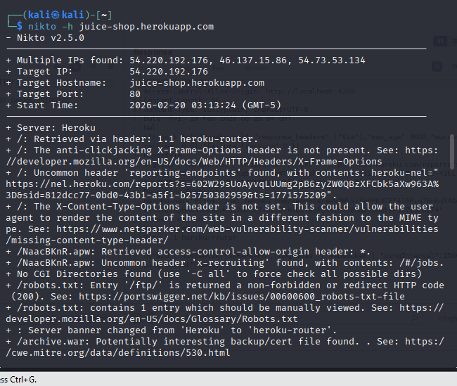
5. Surface Exposure Summary
Category | Exposure Identified | Risk Level
Domain Information | Publicly discoverable | Low
IP & Hosting Details | Cloud-hosted, minimal services exposed | Low
SSL/TLS | Properly configured HTTPS | Low
Server Indicators | Banner disclosure, missing security headers | Medium

6. Security Impact Assessment
The reconnaissance phase revealed no critical exposure but identified informational and configuration weaknesses that could support future attacks if combined with active exploitation techniques.
Primary risks identified:
- Increased attack surface due to server fingerprinting
- Potential client-side attack vectors due to missing security headers
7. Conclusion
Passive and light active reconnaissance successfully identified the exposed surface of the selected website without violating ethical or legal boundaries. While the application implements secure transport mechanisms, several configuration weaknesses and information disclosure points were observed. These findings demonstrate how attackers can gather valuable intelligence during the early stages of an attack lifecycle.
1D. Linking Reconnaissance Findings to the Equifax Breach
1. How Similar Weaknesses Could Contribute to Attacks Like Those in Question 1A
The cyber-attacks analyzed in Question 1A—specifically the Equifax (2017) breach incident—demonstrate how minor security weaknesses, when left unaddressed, can escalate into large-scale compromises.
Findings from the reconnaissance phase (Question 1C) revealed information disclosure through server headers, missing security controls, and publicly accessible infrastructure details. These weaknesses mirror early-stage conditions present in real-world breaches.
For example:
- In the Equifax breach, attackers exploited a known but unpatched web framework vulnerability. Reconnaissance techniques similar to those used in this project could have revealed the presence and version of Apache Struts through server indicators.
Thus, reconnaissance-level weaknesses—such as technology fingerprinting, exposed services, and misconfigurations—serve as enablers for advanced attack stages.
2. Initial Risks Visible from Reconnaissance Alone
Even without exploitation, reconnaissance can reveal several high-impact risks:
2.1 Information Disclosure
Exposed HTTP headers and server banners provide attackers with insight into:
- Web server type
- Application framework
- Security posture
This information allows attackers to tailor exploits based on known vulnerabilities.
2.2 Attack Surface Mapping
Open ports, accessible endpoints, and cloud hosting details help attackers:
- Identify potential entry points
- Prioritize targets
- Reduce the time required for exploitation
2.3 Security Control Weaknesses
The absence of security headers and visible configuration gaps suggest:
- Weak defense-in-depth implementation
- Increased susceptibility to client-side attacks such as clickjacking and cross-site scripting (XSS)
These risks, while subtle, significantly lower the barrier to a successful attack.
3. Why Early Reconnaissance Is Critical in Cyber Attacks
Early reconnaissance is a critical phase in both offensive attacks and defensive security assessments because it:
3.1 Enables Targeted Attacks: Attackers rely on reconnaissance to avoid random exploitation. By identifying technologies, versions, and configurations early, attackers can:
- Select precise exploits
- Reduce noise and detection risk
- Increase success rates
3.2 Reduces Detection: Reconnaissance is often passive or low-noise, allowing attackers to remain undetected for extended periods—similar to the Equifax attackers who remained in the system for months.
3.3 Supports Kill Chain Progression: Reconnaissance is the first stage of the cyber kill chain. Weaknesses discovered at this stage directly influence:
- Initial access methods
- Privilege escalation paths
- Lateral movement opportunities
3.4 Demonstrates Defensive Gaps: From a defensive perspective, reconnaissance highlights how much information an organization unintentionally exposes, emphasizing the importance of:
- Proper configuration management
- Patch management
- Continuous monitoring
4. Overall Assessment
The findings from Questions 1A through 1C demonstrate that major cyber incidents rarely begin with sophisticated attacks. Instead, they often start with simple reconnaissance that uncovers small weaknesses. When combined with poor patching, weak access controls, or misconfigurations, these weaknesses can lead to catastrophic breaches like those experienced by Equifax, Facebook, and Quora.
CONCLUSION
Reconnaissance of OWASP Juice Shop revealed similar types of surface weaknesses that attackers exploited in real-world incidents like the Equifax breach. Early detection and mitigation of such weaknesses—through secure configurations, patch management, and hardened headers—are essential to prevent attackers from using public information to mount larger attacks.
Ethical reconnaissance, when performed responsibly, is a powerful tool for understanding potential threats and bridging the gap between theoretical knowledge and real-world cybersecurity practice.

